Sample NHS Application Responses



[Grab your reader’s attention with a great quote from the document or use this space to emphasize a key point. To place this text box anywhere on the page, just drag it.]

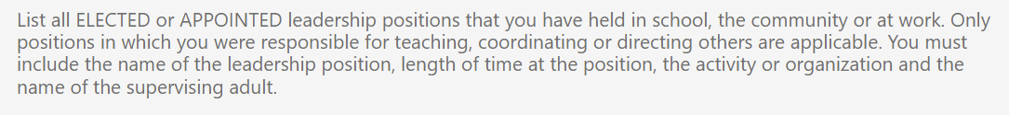

Based on this student’s responses, 8 Activity Verification forms must be submitted on their behalf, one for each supervising adult!